CMIS 141 Final

**Test Case 1**

|  |  |  |  |
| --- | --- | --- | --- |
| **Input** | **Expected Output** | **Actual Output** | **Pass?** |
| **1** | **\*\*\*\*\*\*\*\*\*\* Population Growth \*\*\*\*\*\*\*\*\*\*\*\*\*\*\*\*\*\*\*\*\*\*\*\*\*\***  **1994-1995: .95%**  **1995-1996: .92%**  **1996-1997: .96%**  **1997-1998: .92%**  **1998-1999: .9%**  **1999-2000: 3.2%**  **2000-2001: 1.38%**  **2001-2002: .93%**  **2002-2003: .98%**  **2003-2004: .99%**  **2004-2005: .97%**  **2005-2006: .98%**  **2006-2007: .74%**  **2007-2008: .81%**  **2008-2009: .97%**  **2009-2010: .76%**  **2010-2011: .73%**  **2011-2012: .73%**  **2012-2013: .72%**  **Enter the number of the question you want answered. Enter ?0? to quit the program :**  **1. What were the percentages in population growth for each consecutive year from 1994 to 2013?**  **2. What year was the Murder rate the highest?**  **3. What year was the Murder rate the lowest?**  **4. What year was the Robbery rate the highest?**  **5. What year was the Robbery rate the lowest?**  **6. What was the total percentage change in Motor Vehicle Theft between 1998 and 2012?**  **7. What year was the Assault rate the highest?**  **8. What year was the Assault rate the lowest?**  **0. Quit the program**  **Enter your selection:** | **\*\*\*\*\*\*\*\*\*\* Population Growth \*\*\*\*\*\*\*\*\*\*\*\*\*\*\*\*\*\*\*\*\*\*\*\*\*\***  **1994-1995: .95%**  **1995-1996: .92%**  **1996-1997: .96%**  **1997-1998: .92%**  **1998-1999: .9%**  **1999-2000: 3.2%**  **2000-2001: 1.38%**  **2001-2002: .93%**  **2002-2003: .98%**  **2003-2004: .99%**  **2004-2005: .97%**  **2005-2006: .98%**  **2006-2007: .74%**  **2007-2008: .81%**  **2008-2009: .97%**  **2009-2010: .76%**  **2010-2011: .73%**  **2011-2012: .73%**  **2012-2013: .72%**  **Enter the number of the question you want answered. Enter ?0? to quit the program :**  **1. What were the percentages in population growth for each consecutive year from 1994 to 2013?**  **2. What year was the Murder rate the highest?**  **3. What year was the Murder rate the lowest?**  **4. What year was the Robbery rate the highest?**  **5. What year was the Robbery rate the lowest?**  **6. What was the total percentage change in Motor Vehicle Theft between 1998 and 2012?**  **7. What year was the Assault rate the highest?**  **8. What year was the Assault rate the lowest?**  **0. Quit the program**  **Enter your selection:** | **Yes** |

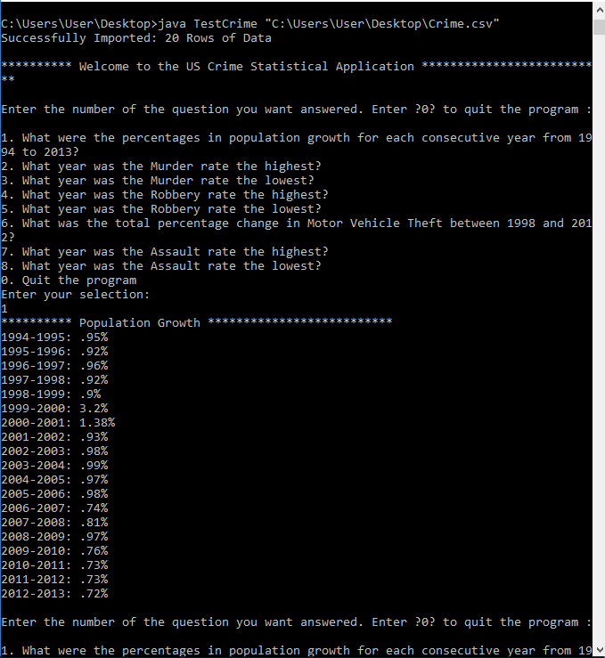

**Test Case 2**

|  |  |  |  |
| --- | --- | --- | --- |
| **Input** | **Expected Output** | **Actual Output** | **Pass?** |
| **2** | **\*\*\*\*\*\*\*\*\*\* Highest Murder Rates \*\*\*\*\*\*\*\*\*\*\*\*\*\*\*\*\*\*\*\*\*\*\*\*\*\***  **High Murder Rate 1994 : 9.0%**  **Enter the number of the question you want answered. Enter ?0? to quit the program :**  **1. What were the percentages in population growth for each consecutive year from 1994 to 2013?**  **2. What year was the Murder rate the highest?**  **3. What year was the Murder rate the lowest?**  **4. What year was the Robbery rate the highest?**  **5. What year was the Robbery rate the lowest?**  **6. What was the total percentage change in Motor Vehicle Theft between 1998 and 2012?**  **7. What year was the Assault rate the highest?**  **8. What year was the Assault rate the lowest?**  **0. Quit the program**  **Enter your selection:** | **\*\*\*\*\*\*\*\*\*\* Highest Murder Rates \*\*\*\*\*\*\*\*\*\*\*\*\*\*\*\*\*\*\*\*\*\*\*\*\*\***  **High Murder Rate 1994 : 9.0%**  **Enter the number of the question you want answered. Enter ?0? to quit the program :**  **1. What were the percentages in population growth for each consecutive year from 1994 to 2013?**  **2. What year was the Murder rate the highest?**  **3. What year was the Murder rate the lowest?**  **4. What year was the Robbery rate the highest?**  **5. What year was the Robbery rate the lowest?**  **6. What was the total percentage change in Motor Vehicle Theft between 1998 and 2012?**  **7. What year was the Assault rate the highest?**  **8. What year was the Assault rate the lowest?**  **0. Quit the program**  **Enter your selection:** | **Yes** |

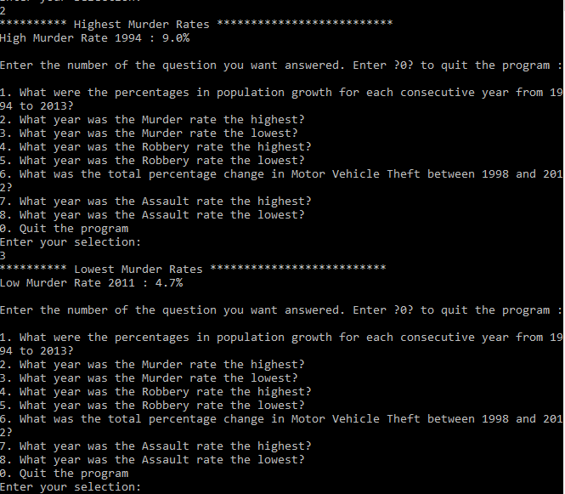

**Test Case 3**

|  |  |  |  |
| --- | --- | --- | --- |
| **Input** | **Expected Output** | **Actual Output** | **Pass?** |
| **4** | **\*\*\*\*\*\*\*\*\*\* Highest Robbery Rates \*\*\*\*\*\*\*\*\*\*\*\*\*\*\*\*\*\*\*\*\*\*\*\*\*\***  **High Robbery Rate 1994 : 237.8%**  **Enter the number of the question you want answered. Enter ?0? to quit the program :**  **1. What were the percentages in population growth for each consecutive year from 1994 to 2013?**  **2. What year was the Murder rate the highest?**  **3. What year was the Murder rate the lowest?**  **4. What year was the Robbery rate the highest?**  **5. What year was the Robbery rate the lowest?**  **6. What was the total percentage change in Motor Vehicle Theft between 1998 and 2012?**  **7. What year was the Assault rate the highest?**  **8. What year was the Assault rate the lowest?**  **0. Quit the program**  **Enter your selection:** | **\*\*\*\*\*\*\*\*\*\* Highest Robbery Rates \*\*\*\*\*\*\*\*\*\*\*\*\*\*\*\*\*\*\*\*\*\*\*\*\*\***  **High Robbery Rate 1994 : 237.8%**  **Enter the number of the question you want answered. Enter ?0? to quit the program :**  **1. What were the percentages in population growth for each consecutive year from 1994 to 2013?**  **2. What year was the Murder rate the highest?**  **3. What year was the Murder rate the lowest?**  **4. What year was the Robbery rate the highest?**  **5. What year was the Robbery rate the lowest?**  **6. What was the total percentage change in Motor Vehicle Theft between 1998 and 2012?**  **7. What year was the Assault rate the highest?**  **8. What year was the Assault rate the lowest?**  **0. Quit the program**  **Enter your selection:** | **Yes** |

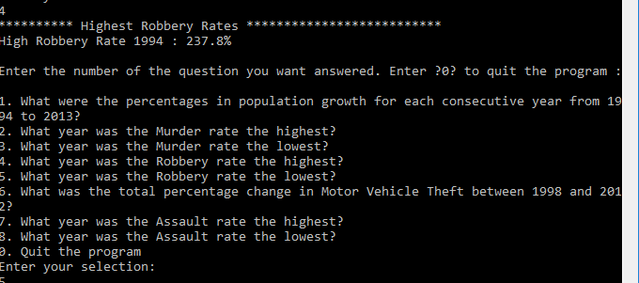

|  |  |  |  |
| --- | --- | --- | --- |
| **Input** | **Expected Output** | **Actual Output** | **Pass?** |
| **0** | **Thank you for trying the US Crimes Statistic Program**  **Elapsed time in seconds was: 1026** | **Thank you for trying the US Crimes Statistic Program**  **Elapsed time in seconds was: 1026** | **Yes** |

